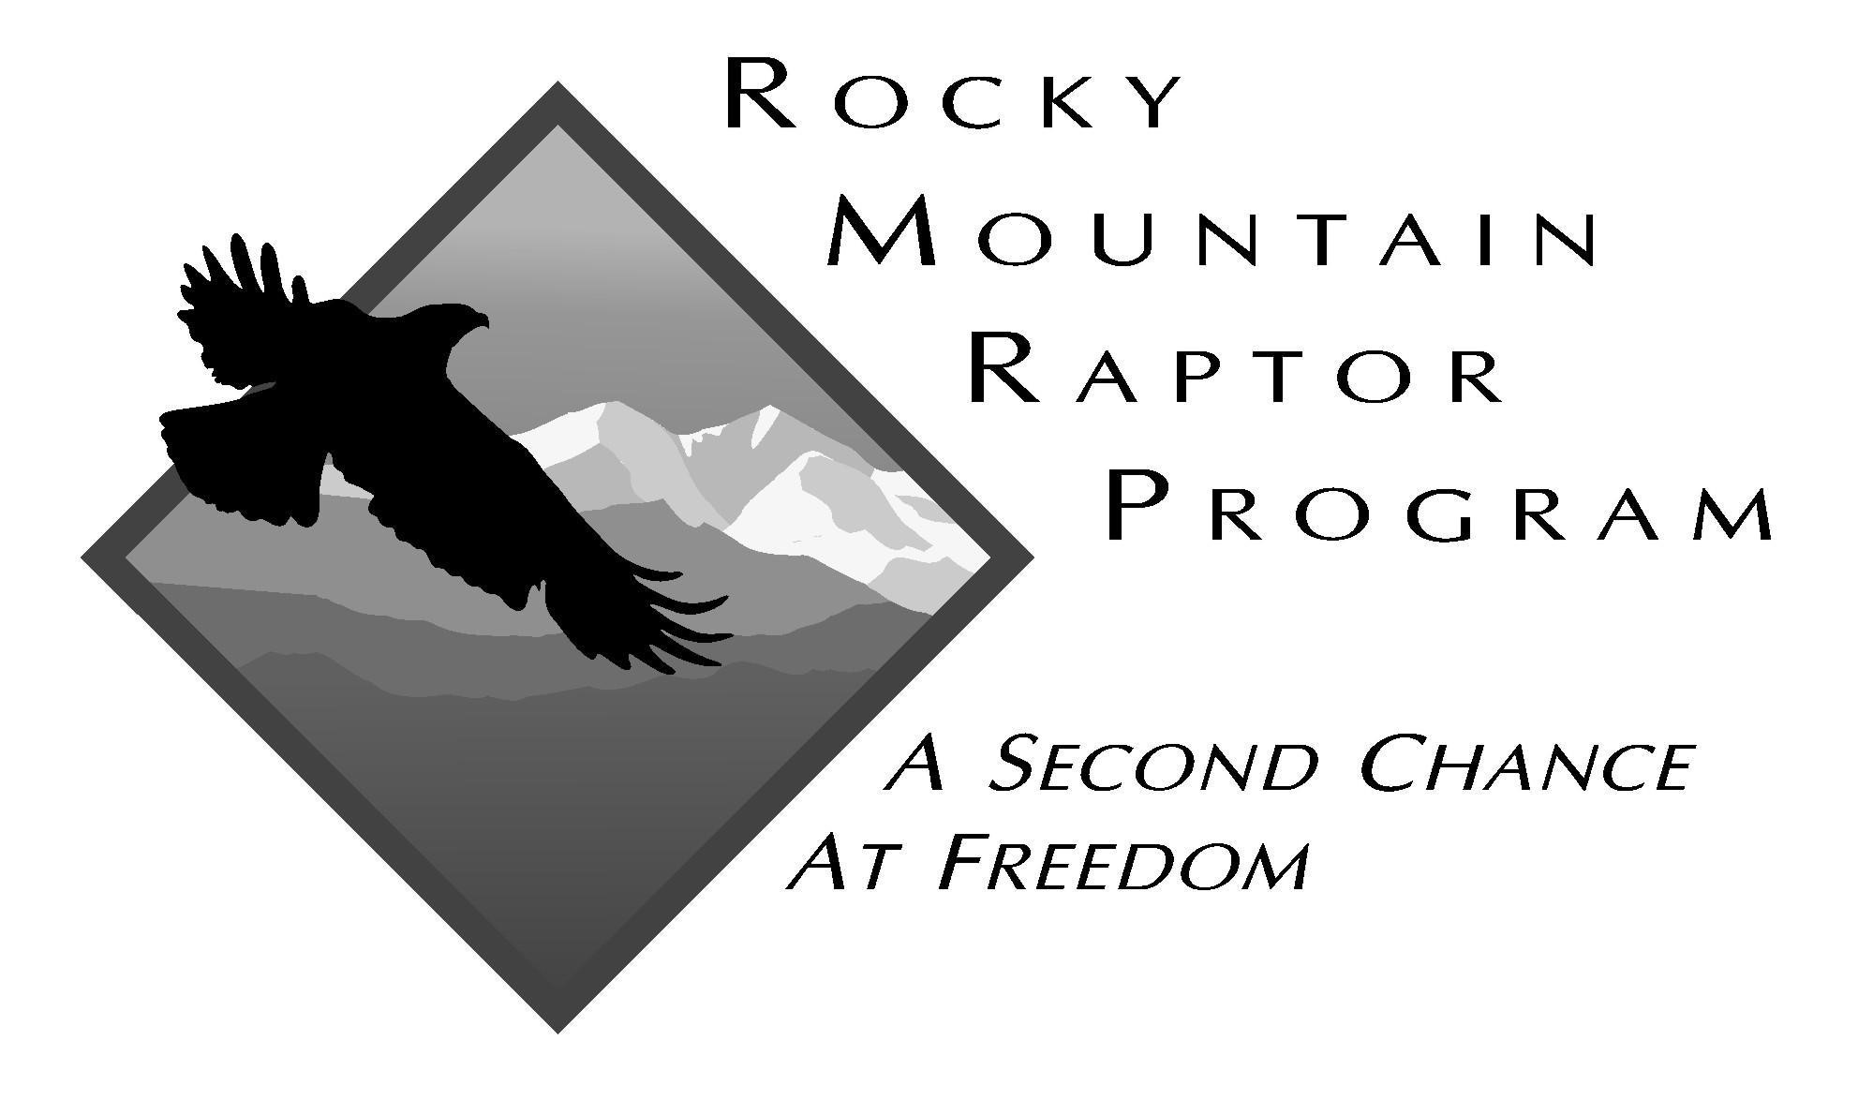
Rocky Mountain Raptor Program
Raptor Rehabilitation Seasonal Internship
With over 37 years of experience in the field of raptor rehabilitation, the Rocky Mountain Raptor Program (RMRP) offers exceptional opportunities for learning about the rescue, care and husbandry, and rehabilitation of a variety of raptor species. The work can be intense and fast-paced, offering the intern an opportunity to gain hands-on experience in a rehabilitation setting and learn skills from diet preparation and general husbandry to safe capture, restraint, and physical assessments. There is also the opportunity to observe triage and other more advanced raptor rehabilitative procedures, and to participate in raptor necropsies.
Internships can be used for academic or vocational purposes, but interns are responsible for making the arrangements necessary with your institution to receive relevant credit as a result of completing the internship. Please notify the RMRP if the internship will be used for this purpose.

Expectations
As an intern at the RMRP you will be expected to work hard and get your hands dirty! There is a lot to learn from our wild raptor patients through their daily care. We are a raptor rehabilitation facility first and foremost, and our main objective is to return our patients to their natural wild habitat once they have been rehabilitated. We look for people that have a thirst for knowledge, a desire to learn, are detail-oriented, and follow written and oral instruction well. We expect to work with enthusiastic, mature, hard-working individuals. The more proactively, reliably, and correctly the intern performs his/her duties, the more responsibility he/she will be given.

Qualifications
Previous experience in animal care is helpful. A degree (or degree in progress) in natural sciences, wildlife management, veterinary medicine, or veterinary technician are preferred, but we will consider interns from all disciplines. We believe that a keen interest in wildlife, enthusiasm, a strong work ethic, and willingness to learn are more important than academic qualifications. This internship is available to individuals in all stages of their careers, from students to retirees.
The nature and demands of rehabilitation require prospective interns to meet the following criteria:
- Be 18 years of age or older
- Submit to and pass a background check
- Have a current tetanus vaccination
- Be in good health/fitness to perform physically demanding tasks, such as bending, lifting, walking on uneven and unimproved surfaces, climbing ladders, and working outdoors in all types of weather
- Possess good oral and written communication skills
- Be able to learn quickly and perform various tasks in a fast paced work environment; work quickly and efficiently while following detailed directions and procedures
- Be able to perform repetitive tasks for extended periods of time
- Be able to work independently as well as a team member in collaboration with volunteers, other interns, and staff

Job Responsibilities
To facilitate the successful rehabilitation of injured, sick, or orphaned raptors the seasonal intern will:
- Develop in depth knowledge surrounding RMRP’s mission, raptor natural history, identification, diseases, behavior, anatomy, physiology, and related medical and conservation challenges
- Demonstrate safe and ethical practices to maintain the welfare and wildness of patients undergoing rehabilitation
- Provide daily husbandry care for rehabilitation patients:
o Bird checks
o Cleaning enclosures
o Maintaining daily patient records
o Food preparation
- Assist staff in the medical care of rehabilitation patients:
o Safe capture and restraint
o Weight checks
o Feather checks and general physical exams
- Provide daily husbandry and enrichment for the live prey colony
- Perform gross necropsies and assist in any ongoing research projects
- Assist with releases
- Assist with patient admissions and rescues (advanced skill)
- Assist with daily facility chores (laundry, sweeping, mopping, etc)
- Assist in various facility repair and maintenance projects:
O Enclosure/hallway disinfection
o Perch repair
o Deep cleaning
o Basic construction

Individual intern experience, skills and performance will determine the range of activities added to his/her responsibilities over time. Advanced duties will not be assigned until the intern has demonstrated an understanding, proficiency, and reliability in basic husbandry and intermediate tasks.

Housing and Transportation
RMRP does not provide housing or transportation. If you are coming from out of town, you will be responsible for finding your own housing. As a college town, Fort Collins offers a broad range of rental opportunities. You are also responsible for arranging your own reliable transportation to and from the facility.

Session Dates and Time Commitment
The seasonal intern position coincides with the busy season for the RMRP and runs from mid-May through August, although the end date is flexible to accommodate students returning to school.
Interns are expected to attend three pre-scheduled classes outside of their regularly scheduled shifts. These classes will occur in the first month of the internship.
Interns will commit to a minimum of four months (completing a minimum of 200 hours), usually in 5-10 hour shifts. Shifts run 7am-12pm or 7am-6pm, with an hour lunch break. Interns generally work at least one half day and one full day shift per week (you may request additional hours or shifts, if interested).
Weekend/holiday hours may be required.
All internship positions are unpaid and subject to a 3 week probationary assessment.

Application Process
If you are interested in our seasonal intern position, fill out the application linked below (open Jan 1st - March 31st). Please note that a limited number of internships are available and the position is highly competitive. Successful candidates will be contacted for an interview.
There is a one-time $35 administration fee for applicants who are accepted into the program. This off-sets costs such as a background check, name badge, and a volunteer t-shirt.
If you need more information or have further questions, please contact our Rehabilitation and Research Assistant, Carrie, at carrie@rmrp.org.

